## Improved global estimation of seasonal variations in C3 photosynthetic capacity based on eco-evolutionary optimality hypotheses and remote sensing

Yihong Liu a, Jing M. Chen a, b *, Mingzhu Xu b, Rong Wang b, Weiliang Fan c, Wenyu Li a, Lucas Kammer a, Collin Prentice d, Trevor F. Keenan e, f, Nicholas G. Smith g

*a Department of Geography and Planning, University of Toronto, Toronto, Canada*

*b School of Geographical Sciences, Fujian Normal University, Fuzhou, China*

c School of Environmental and Resources Science, Zhejiang A&F University, Hangzhou, 311300, China

*d Department of Life Sciences, Imperial College London, London, UK*

e Climate and Ecosystem Sciences Division, Lawrence Berkeley National Laboratory, Berkeley, CA, USA

f Department of Environmental Science, Policy and Management, UC Berkeley, Berkeley, CA, USA

g Department of Biological Sciences, Texas Tech University, Lubbock, TX, USA

**⁎** Corresponding author at: Department of Geography and Program in Planning, University of Toronto, Toronto, Canada, and School of Geographical Sciences, Fujian Normal University, Fuzhou, China.

E-mail address: jing.chen@utoronto.ca (JM. Chen)

**Abstract**

The maximum carboxylation rate (*Vcmax*) at 25°C (*Vcmax25*) is a fundamental parameter in terrestrial biosphere models (TBMs) to estimate carbon assimilation of C3 biomes. Global *Vcmax* or *Vcmax25* datasets with acceptable accuracy are very limited, while it has been reported that considerable uncertainties in TBMs are induced by the parameterization of *Vcmax25*. Recently, a model was developed to estimate *Vcmax* by combining climate data and eco-evolutionary optimality hypotheses, which hypothesized that plants acclimate to the environment to achieve maximum carbon assimilation with minimum related costs. However, this optimality-based model has not yet been applied to capture global-scale seasonal variations in *Vcmax*, partly due to the lack of parameterization on how the acclimation of *Vcmax25* to the environment is constrained by photosynthetic nitrogen other than RuBisCO. Here, we used remote sensing methods to estimate leaf absorptance of radiation and the ratio of the maximum electron transport rate (*Jmax*) to *Vcmax* at 25°C (*rJV25*), which contain photosynthetic nitrogen information related to light harvesting, electron transport, and carboxylation. Then, these two parameters were incorporated into the optimality-based model to constrain *Vcmax25* of C3 biomes. The simulated *Vcmax25* agreed well with seasonal variations in field-measured *Vcmax25* at 18 sites (R2 = 0.80, RMSE = 11.57 μmol·m-2·s-1). Our results indicated that variations in leaf absorptance and *rJV25* contributed to the variation in *Vcmax25*. The influence of leaf absorptance on *Vcmax25* was primarily affected by the irradiance level, while *rJV25* was determined by the growing season mean temperature. The simulated *Vcmax25* had large spatiotemporal variations on the global scale, and the environment drove the variation pattern more greatly than the biome distribution. With reasonably accurate seasonal variations in *Vcmax25*, our model can help improve the global carbon cycle and leaf trait modelling.

Keywords

Carbon cycle, carboxylation, coordination theory, electron transport, least-cost theory, *Jmax*, photosynthetic nitrogen, *Vcmax*.

**1 Introduction**

The majority of terrestrial biosphere models (TBMs) estimate photosynthetic CO2 assimilation of C3 biomes based on the Farquhar, von Caemmerer, and Berry (FvCB) model (Farquhar et al., 1980; von Caemmerer & Farquhar, 1981; von Caemmerer, 2000), in which the maximum Ribulose-1,5-bisphosphate carboxylase/oxygenase (RuBisCO) carboxylation rate (*Vcmax*) at a standard temperature (often 25 °C; *Vcmax25*) is a fundamental parameter determining the photosynthetic capacity of plant leaves (Rogers et al., 2017a). *Vcmax25* has been empirically estimated from leaf nitrogen content and set as constants based on plant functional types (PFTs) over the growing season in TBMs (Kattge et al., 2009; Rogers, 2014; Walker et al., 2014). However, both *Vcmax* and *Vcmax25* have been observed to show considerable spatial and temporal variations during the growing season, even within the same PFT (Alton, 2018; Chen et al., 2022; Dong et al., 2022; He et al., 2019; Liu et al., 2023; Luo et al., 2019; Smith et al., 2019). Uncertainties in TBM estimates of photosynthesis were reported to be caused by the parameterization of *Vcmax25*, and the incurred biases in simulated gross primary productivity (GPP) were estimated to be up to 34 PgC ·year-1 (Bonan et al., 2011; Luo et al., 2019; Rogers, 2014; Schaefer et al., 2012; Walker et al., 2017). Capturing the spatial and temporal variations in *Vcmax25* on the global scale is an important step in improving carbon cycle modelling by TBMs (Rogers et al., 2017a).

Some global *Vcmax* or *Vcmax25* datasets have been produced using remote sensing methods. With the latest development in LCC retrieval algorithms, global LCC datasets (Croft et al., 2020; Xu et al., 2022a, b) are available to be a proxy (Croft et al., 2017) to estimate the seasonal variations in *Vcmax25* empirically (Alton, 2018; Luo et al., 2019). However, the accuracy of the estimated *Vcmax25* is limited by the robustness of the empirical relationships between *Vcmax25* and LCC. The empirical relationships have been shown to vary at different sites even within the same PFT in previous studies (Chou et al., 2020; Croft et al., 2017; Houborg et al., 2013, 2015; Lu et al., 2022; Qian et al., 2021; Wang et al., 2020), despite the strong correlations. Remotely sensed solar-induced chlorophyll fluorescence (SIF), a widely used proxy of GPP (Frankenberg et al., 2011; Guanter et al., 2012; Sun et al., 2017), has been used as a GPP constraint to invert *Vcmax* from GPP models (He et al., 2019; Zhang et al., 2014, 2018). He et al. (2019) developed a data assimilation scheme to retrieve *Vcmax* globally from SIF in a process-based GPP model. However, seasonal variations in *Vcmax* were not captured accurately in He et al. (2019) because SIF itself did not correlate with *Vcmax* well temporally, making it error-prone to derive the temporal trend of *Vcmax* using this data assimilation scheme. Liu et al. (2023) incorporated LCC data into this data assimilation scheme to simulate the temporal trend of *Vcmax*. The retrieved *Vcmax* agreed with field measurements at 210 sites. The refined method greatly reduced its dependence on empirical relationships between LCC and *Vcmax25* through an initialization process and captured seasonal variations in *Vcmax* more accurately than using SIF alone. Despite the improved accuracy compared to previous remote sensing methods, this refined data assimilation scheme had high requirements on computational resources. Also, remotely sensed SIF datasets with high spatiotemporal resolutions (e.g., TROPOMI SIF) only have data after the year 2018, limiting the method to capture the long-term variations in photosynthetic capacity.

In addition to remotely sensed plant physiological data, climate data were used to produce global *Vcmax* maps based on eco-evolutionary optimality hypotheses (Dong et al., 2022; Smith et al., 2019), which hypothesized that plants maximize carbon assimilation with minimum associated costs based on the least-cost theory (Wright et al., 2003; Prentice et al., 2014) and the coordination hypothesis (Chen et al., 1993; Maire et al., 2012; Wang et al., 2017). Plants were assumed to 1) adjust their nitrogen allocation optimally to balance electron transport and carboxylation and 2) adjust their stomata optimally to maintain photosynthesis at the lowest cost in respiration. Based on eco-evolutionary optimality hypotheses, *Vcmax* can be estimated mechanistically as a function of incident radiation, air temperature, vapor pressure deficit, atmospheric pressure, and atmospheric CO2 concentration. Although many versions of the optimality-based model have been developed and used to simulate *Vcmax* or *Vcmax25* (Dong et al., 2022; Jiang et al., 2020; Peng et al., 2021; Smith et al., 2019), a global dataset with seasonal variations has not been produced and tested, partly due to the lack of global information to parameterize the photosynthetic nitrogen related to the light harvesting and electron transport processes, which may constrain the acclimation of *Vcmax25* to the environment.

The number of photons absorbed by plant leaves is determined not only by the irradiance level but also by the leaf absorptance of photosynthetically active radiation, which was largely found to be determined by LCC (Evans, 1989; Evans & Poorter, 2001; Lambers et al., 2008; Jacquemoud & Baret, 1990). LCC contains the photosynthetic nitrogen pool related to light harvesting (Croft et al., 2017; Evans, 1989; Hikosaka & Terashima, 1996; Lu et al., 2020; Luo et al., 2021), since the incident light to plant leaves is absorbed by chlorophyll to excite electrons for photosynthesis. Considerable spatial and seasonal variations in LCC have been demonstrated globally (Croft et al., 2020; Xu et al., 2022a, b), so leaf absorptance may thus vary spatially and temporally. We hypothesized that the seasonal variation in the photosynthetic nitrogen responsible for light harvesting affects the seasonal variation in *Vcmax25* by controlling the absorbed photons of plant leaves besides the irradiance level. Variations in photosynthetic nitrogen related to light harvesting constrain the response of carboxylation to the light availability of the environment, which may be manifested in the temporal variation in leaf absorptance. The optimality-based model can thus track the variation in *Vcmax25* more accurately after incorporating the variations in leaf absorptance into the model. Given that regulatory mechanisms exist in plant leaves to modulate electron transport and RuBisCO activity to utilize the available light and CO2 maximally (Chen et al., 1993; Woodrow & Berry, 1988), The ratio of the maximum electron transport rate (*Jmax*) to *Vcmax* (*rJV*) at 25°C (*rJV25*) has been considered as a result of the trade-off between photosynthetic gain and cost of energy dissipation (Niinemets & Tenhunan, 1997; Walker et al., 2014; Xu et al., 2012), indicating the reallocation of photosynthetic nitrogen between electron transport and carboxylation. According to field measurements in previous studies, *rJV25* was found to vary at different sites and correlate to the air temperature over the growing season (Kattge & Knorr, 2007; Mission et al., 2006; Roger et al., 2017b). Although *rJV* was predicted using the optimality-based model based on the assumption that photosynthesis is equally limited by electron transport and carboxylation under average environmental conditions (Smith et al., 2020), we hypothesized that parameterizing *rJV25* in advance and using it to constrain the optimality-based model may further improve the model performance because *rJV25* shifts the balance between electron transport and carboxylation. The balance affected how the photosynthetic nitrogen demand for RuBisCO, i.e., *Vcmax25*, acclimates to the environment. As *rJV25* has not been widely tested, the parameterized *rJV25* also provides an opportunity for this test on the global scale.

To test our hypotheses, here, we estimated leaf absorptance and *rJV25* globally based on remote sensing methods, and the two derived parameters were incorporated into the optimality-based model to produce a global *Vcmax25* dataset with seasonal variations. The simulated *Vcmax25* was compared to field measurements collected from past literature at 18 sites over the growing season to evaluate the model performance. The influence of environmental and physiological controls on field measurements was also analyzed. On the global scale, we demonstrated the seasonal variations in simulated *Vcmax25* and analyzed the influence of leaf absorptance and *rJV25*.

**2** **Data and methods**

**2.1 The optimality-based model to simulate *Vcmax25***

*Vcmax25* was simulated directly in this study rather than *Vcmax* for two reasons. First, field measurements from past literature to validate the results were measured at 25°C or had been standardized to 25°C. Second, TBMs often adopt *Vcmax25* as input (Rogers, 2014), and *Vcmax25* is useful in estimating leaf nitrogen or other leaf traits (Dong et al., 2022; Lu et al., 2020; Luo et al., 2021). Accurate *Vcmax25* estimates will directly contribute to the global carbon cycle and leaf trait modelling.

RuBP regeneration-limited carboxylation rate () was assumed to equal the RuBisCO capacity-limited carboxylation rate () under average environmental conditions to maximize the use of leaf nitrogen in eco-evolutionary optimality hypotheses. According to the FvCB model, the equation can be expressed as:

|  |  |  |
| --- | --- | --- |
|  | = | (1) |

where (μmol·m-2·s-1) refers to the electron transport rate, (Pa) refers to the intercellular CO2 concentration, (Pa) refers to the CO2 compensation point in the absence of mitochondrial respiration, (Pa) is the intercellular O2 concentration, and (Pa) and (Pa) are Michaelis–Menten coefficients of RuBisCO activity for CO2 and O2, respectively.

can be expressed as:

|  |  |  |
| --- | --- | --- |
|  |  | (2) |

where *I* (μmol·m-2·s-1) is the incoming photosynthetic photon flux density, and (mol·mol-1) represents the fraction of incident quanta utilized in electron transport, determined as:

|  |  |  |
| --- | --- | --- |
|  |  | (3) |

where is the leaf absorptance calculated from remotely-sensed LCC in this study (Details are introduced in Section 2.2), 0.5 represents that half of the absorbed light reaches photosystem II (Farquhar et al., 1980), and is the maximum quantum yield of photosystem II, which can be determined from air temperature (*T*; °C) (Bernacchi et al., 2003) as:

|  |  |  |
| --- | --- | --- |
|  |  | (4) |

*Ci* can be calculated from the atmospheric CO2 partial pressure (*Ca*; Pa) by estimating the optimal ratio () of *Ci* to *Ca* based on the least-cost theory (Prentice et al., 2014) as:

|  |  |  |
| --- | --- | --- |
|  |  | (5) |

where defines the sensitivity of to the vapor pressure deficit (*Dg*; Pa) that can be determined as:

|  |  |  |
| --- | --- | --- |
|  |  | (6) |

where (unitless) describes the ratio of the cost factor for photosynthesis to the cost factor for transpiration, is the viscosity of water relative to its value at 25°C.

In this study, we adopted the value of each parameter at 25°C without applying the temperature response function to convert the parameter to its value at other temperatures. Eqs. 1, 5, and 6 can then be expressed as:

|  |  |  |
| --- | --- | --- |
|  |  | (7) |
|  |  | (8) |
|  |  | (9) |

was set as 146 following Smith et al. (2019). , , and can be determined from widely adopted literature values in Bernacchi et al. (2001) and atmospheric pressure (*Ps*; MPa) as:

|  |  |  |
| --- | --- | --- |
|  |  | (10) |
|  |  | (11) |
|  |  | (12) |

To solve *Vcmax25* in Eq. 7, *Jmax25* is expressed as:

|  |  |  |
| --- | --- | --- |
|  |  | (13) |

*Vcmax25* can be solved after substituting Eqs. 13 into Eq. 7 as:

|  |  |  |
| --- | --- | --- |
|  |  | (14) |

where

|  |  |  |
| --- | --- | --- |
|  |  | (15) |

*rJV25* in Eq. 14 was estimated globally using a remote sensing method in this study (Details are introduced in Section 2.2). In this study, we solved *Vcmax25* (Eq. 14) differently from other published versions of the optimality-based model, e.g., a recent version in Peng et al. (2021), in order to incorporate the variations in *rJV25* to constrain *Vcmax25*.

**2.2 Estimating leaf absorptance and** *rJV25* **using remote sensing methods**

The light absorptance of leaves at the top of the canopy was calculated using the PROSPECT leaf radiative transfer model (Feret et al., 2008; Jacquemoud & Baret, 1990) with the remotely-sensed LCC input. In the PROSPECT model, leaf absorptance of radiations from 400 to 2500 nm can be simulated with inputs of LCC (μg·cm-2) and other five parameters: structure parameter (*N*; unitless), carotenoid content (*Car*; μg·cm-2), brown pigment (*Cb*; in arbitrary units), dry matter (*Cm*; g·cm-2), and equivalent water thickness (*Cw*; g·cm-2). We set these five leaf parameters in PROSEPECT for each PFT following Croft et al. (2020), who collected these values from field measurements or model inversion results from past literature (Table S1).

To estimate *rJV25*, we first produced a global *Vcmax25* dataset based on a remote sensing method. The global *Vcmax25* dataset was retrieved in a refined data assimilation scheme (Liu et al., 2023) from the MODIS LCC dataset (Xu et al., 2022a) and GPP estimated from the TROPOMI SIF dataset (Köhler et al., 2018) based on empirical non-linear relationships (Liu et al., 2022). MODIS LCC was used here instead of the MERIS LCC dataset (Croft et al., 2020) used in Liu et al. (2023) because MODIS LCC covers more years and matches TROPOMI SIF better. The retrieved *Vcmax25* dataset here is named as RS-*Vcmax25* in the following sections for clarity. We then substituted the mean values of RS-*Vcmax25* and other environmental inputs over the growing season into Eq. 14 to estimate *rJV25* (RS-*rJV25*). Similar to the definition in Smith et al. (2019), the growing season was operationally defined in this study as days with mean temperatures higher than 0 °C. *rJV25* has been found to correlate to air temperature over the growing season (Kattge & Knorr, 2007; Mission et al., 2006; Roger et al., 2017b), and both linear (Kattge & Knorr, 2007) and exponential (Smith et al., 2020) functions have been exploratively established to study the influence of air temperature on *rJV* or *rJV25*. Here, we used both linear and exponential functions to fit the relationship between the growth temperature (*Tg*; °C), i.e., the mean temperature over the growing season, and RS-*rJV25* (Fig. S1a). The exponential one was finally adopted to estimate *rJV25* because of the higher R2 than the linear one. The exponential relationship is expressed as:

|  |  |
| --- | --- |
|  | (16) |

The established empirical relationship in Eq. 16 is named as RS-empirical relationship in the following sections. *Vcmax25* was then solved as:

|  |  |  |
| --- | --- | --- |
|  |  | (17) |

We did not use the RS-*rJV25* directly but estimated *rJV25* empirically from *Tg* in order to reduce the dependence of the simulated *Vcmax25* on RS-*Vcmax25*.

**2.3 Field measurements of *Vcmax25* and *rJV25***

To evaluate the model performance, we collected field-measured *Vcmax25* at 18 sites that had at least three measurements over the growing season from past literature. These field measurements were calculated from gas exchange measurements of net photosynthesis to intercellular CO2 (*A*/*Ci*) curves, covering evergreen needleleaf forests (ENF), evergreen broadleaf forests (EBF), deciduous broadleaf forests (DBF), savannas (SAV), grasslands (GRA), and croplands (CRO). These 18 sites were selected because 1) measurements were made on sunlit leaves on the top of the canopy, 2) *rJV25* was measured and provided along with *Vcmax25*, and 3) the site is covered by MODIS LCC data. These 18 sites included the validation sites in Jiang et al. (2020) that fulfilled the above three criteria. Field measurements of *rJV25* were used to evaluate the robustness of the model and the reliability of the empirical relationship between RS-*rJV25* and *Tg* established in Section 2.2. Field-measured , , and LCC were used in the model if provided in the literature. The detailed information on these 18 sites is shown in Table 1.

**Table. 1** Site information

|  |  |  |  |  |  |  |  |
| --- | --- | --- | --- | --- | --- | --- | --- |
| **Site** | **Latitude (°)** | **Longitude (°)** | **Year** | ***rJV25*** | **PFT** | **Provided data** | **Reference** |
| 1 | -33.62 | 150.74 | 2014 | 1.75 | GRA | \ | Pathare et al. (2017) |
| 2 | 42.67 | 141.60 | 2012 | 1.96 | DBF | \ | Yamaguchi et al. (2016) |
| 3 | 36.17 | 140.22 | 2019 | 1.93 | ENF | \ | Kenzo et al. (2021) |
| 4 | 35.75 | 139.33 | 2001-2002 | 2.32 | ENF | \ | Han et al. (2004) |
| 5 | 36.20 | 139.17 | 2019 | 2.02 | DBF | \ | Tanazawa et al. (2021) |
| 6 | 36.92 | 138.77 | 2002 | 2.00 | DBF | \ | Iio et al. (2008) |
| 7 | 35.07 | 135.72 | 2003-2004 | 1.94 | EBF | \ | Miyazawa & Kikuzawa (2006) |
| 8 | 31.15 | 119.02 | 2016 | 1.89 | CRO | LCC | Chou et al. (2020) |
| 9 | 26.74 | 115.06 | 2017 | 2.03 | ENF | LCC | Wang et al. (2020) |
| 10 | 61.85 | 24.29 | 2011 | 3.69 | ENF |  | Kolari et al. (2014) |
| 11 | 44.69 | 11.09 | 2001 | 1.80 | DBF | \ | Grassi et al. (2005) |
| 12 | -16.66 | -56.80 | 2009-2010 | 1.55 | EBF |  | Dalmagro et al. (2013) |
| 13 | 47.00 | -71.00 | 2002-2003 | 3.80 | ENF |  | Bigras & Bertrand (2006) |
| 14 | 42.54 | -72.17 | 2010 | 2.07 | DBF | \ | Dillen et al. (2012) |
| 15 | 44.32 | -79.93 | 2014 | 1.98 | DBF | LCC | Croft et al. (2017) |
| 16 | 40.03 | -88.23 | 2001 | 1.89 | CRO | \ | Bernacchi et al. (2005) |
| 17 | 38.90 | -120.63 | 2003 | 1.60 | ENF | \ | Mission et al. (2006) |
| 18 | 38.43 | -120.97 | 2006 | 1.77 | SAV | \ | Osuna et al. (2015) |

**2.4 Data used to simulate *Vcmax25***

The MODIS LCC dataset used in this study was retrieved from MODIS reflectance data using a matrix system with two pairs of vegetation indices (Xu et al., 2022a), which captured 77% of variations in the validation dataset with a RMSE of 6.9 μg·cm-2. This LCC dataset covers data from the year 2000 to 2020 with a spatial resolution of 500 m and a temporal resolution of 8 days.

The optimality-based model was driven by climate data of 2-meter air temperature, surface atmosphere pressure, surface incoming shortwave flux, and 2-meter relative humidity in the MERRA-2 meteorological dataset (Gelaro et al. 2017). The incoming shortwave radiation flux on the surface was converted to *I* by multiplying a conversion factor of 2.29 (McCree, 1972). *Dg* (Pa) was calculated from the relative humidity (*RH*; %) and *T* (°C) (Tetens, 1930) as:

|  |  |
| --- | --- |
|  | (18) |

*Ca* was taken as the global mean value of each year from the open-source dataset on the NASA webpage (https://gml.noaa.gov/webdata/ccgg/trends/co2/co2_mm_mlo.txt).

Since the eco-evolutionary optimality hypotheses are based on averaged environmental conditions and MODIS LCC has an 8-day resolution, we ran the model globally using climate inputs *I, Dg*, and *Ps* that were averaged every 8 days in order to match the estimation dates of MODIS LCC. At the site level, input data were extracted based on the latitudes and longitudes of 18 sites. To match with the field-measured *Vcmax25* better, *I, Dg*, and *Ps* were averaged every 8 days around the measurement dates of *Vcmax25*, while the input LCC was taken as MODIS LCC at the closest estimation date to the field measurement date.

**2.5 Experiment schemes for *Vcmax25* modelling**

In this study, we conducted 6 experiment schemes (Table 2) to test our hypothesis that variations in leaf absorptance and *rJV25* reflect the constraint of photosynthetic nitrogen other than RuBisCO on variations in *Vcmax25*. In Scheme 1, leaf absorptance, , was estimated from the PROSPECT model with LCC input, *rJV25* was adopted as field-measured values, and *Vcmax25* was simulated using the new solution proposed in this study (Eq. 14) that directly incorporated the variations in *rJV25* to constrain simulated *Vcmax25*. Scheme 1 contains information on the response of *Vcmax25* to variations in LCC and the nitrogen partitioning between electron transport and carboxylation. In Scheme 2, was set as a fixed value of 75% calculated from a of 0.257 estimated in Smith et al. (2019), while the other settings were the same as Scheme 1. The comparison between Schemes 1 and 2 indicates the influence of variations in leaf absorptance and hence LCC on *Vcmax25*. Scheme 3 kept its settings the same as Scheme 1 except for adopting a fixed *rJV25* value of 1.97, which was the averaged value of field measurements in a previous study (Kattge & Knorr, 2007) and was used in some TBMs, e.g., CLM4 (Bonan et al., 2011). The comparison between Schemes 1 and 3 demonstrates the influence of variations in *rJV25* on *Vcmax25*. In Scheme 4, *rJV25* was estimated from *Tg* using the empirical relationship established in Section 2.2 based on RS-*rJV25*, while other settings were the same as Scheme 1. The comparison between Schemes 1 and 4 evaluates the reliability of estimating *rJV25* from *Tg* empirically. Scheme 5 adopted the fixed value while keeping the other settings the same as Scheme 4. The influence of variations in LCC on *Vcmax25* on the global scale was demonstrated by comparing Schemes 4 and 5 globally. In Scheme 6, we used a recent version of the optimality-based model (Peng et al., 2021) that did not incorporate *rJV25* in the model formulation with a fixed over the growing season. The comparison between Schemes 1 and 6 demonstrates the combined influence of variations in leaf absorptance and *rJV25* on simulated *Vcmax25*.

**Table 2** The setting of the 6 experiment schemes.

|  |  |  |  |
| --- | --- | --- | --- |
| **Scheme** | **(%)** | ***rJV25*** | **Model Structure** |
| 1 | Estimate from LCC | Field measurements | This study |
| 2 | 75 | Field measurements | This study |
| 3 | Estimate from LCC | 1.97 | This study |
| 4 | Estimate from LCC | Estimate from *Tg* | This study |
| 5 | 75 | Estimate from *Tg* | This study |
| 6 | 75 | / | Peng et al. (2021) |

**2.6 Analyses at the site level**

We demonstrated the seasonal variations in simulated *Vcmax25* of Scheme 1 and field measurements at 18 sites to evaluate if *Vcmax25* can be simulated accurately using our modified model. All field measurements at 18 sites were compared to simulated *Vcmax25* of Schemes 1 to 6, individually, to evaluate the influences on *Vcmax25* modelling caused by the incorporation of leaf absorptance and *rJV25*. The coefficient of determination (R2) and root mean square error (RMSE) between simulated *Vcmax25* and field measurements were calculated to assess model performance quantitatively.

We introduced a variable *B* (%) to quantify the difference between Schemes 1 and 2 relative to *Vcmax25*. *B* is expressed as:

|  |  |
| --- | --- |
|  | (19) |

where FM represents field-measured *Vcmax25*. *B* was correlated with *I*, *T*, *Dg*, and field-measured *Vcmax25* at 18 sites. MODIS LCC was also correlated with *I*, *T*, *Dg*, and field-measured *Vcmax25* at these sites to study the relationships between LCC and the environment or *Vcmax25*. Field-measured *Vcmax25* was then evaluated against *I*, *T*, *Dg*, and the product of *I* and (absorbed photosynthetic photon flux density; APAR; μmol·m-2·s-1) to study the influence of the environment on *Vcmax25*, for the purpose of interpreting the optimality-based model. Pearson correlation coefficient (r) was calculated between each dependent and independent variable to quantify the tendency of each dependent variable towards the independent variable.

**2.7 Analyses on the global scale**

The global map and latitudinal distribution of RS-*rJV25* produced in Section 2.2 were demonstrated to show its relationship with *Tg*. To evaluate the reliability of the empirical relationship between RS-*rJV25* and *Tg* established in this study, we compared it with the other two empirical relationships. The first one was established in Kattge & Knorr (2007) from field measurements among 36 plant species as:

|  |  |
| --- | --- |
|  | (20) |

The empirical relationship in Eq. 20 is named as Ref-empirical relationship in the following sections. The second one was established based on the global observational dataset built in Smith et al. (2019) by compiling field measurements recorded in various literature (Bahar et al., 2017; Carswell et al., 2000; De Kauwe et al., 2016; Domingues et al., 2010, 2015; Ellsworth & Crous, 2016; Kattge et al., 2011; Keenan & Niinemets, 2016; Maire et al., 2015; Meir et al., 2002; Niinemets et al., 2015; Rogers et al., 2017b; Serbin et al., 2015; Smith & Dukes, 2017; Tarvainen et al., 2013; Togashi et al., 2018a, b; Wang et al., 2018; Wohlfahrt et al., 1999). Field measurements of the 18 sites in Section 2.3 were also included in this global observational dataset. We tested linear and exponential empirical relationships between *rJV25* and *Tg* based on this dataset (Fig. S1b) and still found that the exponential relationship had a higher R2. The established exponential empirical relationship is expressed as:

|  |  |
| --- | --- |
|  | (21) |

The empirical relationship in Eq. 21 is named as Obs-empirical relationship in the following sections.

Global maps of simulated *Vcmax25* of Scheme 4 at the day of the year (DOY) 9, 97, 185, 273, and 361 were demonstrated to show the spatial distribution of *Vcmax25* at different phases of the growing season. These dates are winter, spring, summer, autumn, and winter for the Northern Hemisphere and summer, autumn, winter, spring, and summer for the Southern Hemisphere. To demonstrate the influence of variations in leaf absorptance on *Vcmax25*, the difference between Schemes 4 and 5 relative to Scheme 4 was demonstrated globally at the five dates. Also, we did a sensitivity analysis globally between and the difference between Schemes 4 and 5. The global map was divided into eight latitudinal regions, and the mean *I, Dg*, and *Ps* in each region at the given DOY were derived as constants to run Schemes 4 and 5. was incrementally perturbed in Scheme 4 from its minimum value to the maximum value in the region at the given DOY. The difference between Schemes 4 and 5 was then plotted with the difference between and 75% in each region. Then, we calculated the mean values of Scheme 4 for each PFT and latitudinal region at each simulation date to demonstrate the global patterns of seasonal variations in *Vcmax25*, where the dominant PFT at each pixel was determined according to the MODIS global land cover product (Friedl et al., 2002).

## 3 Results

### 3.1 Comparison between simulated *Vcmax25* and field measurements

The variations in simulated *Vcmax25* of Scheme 1 (LCC-based leaf absorptance and field-measured *rJV25*) and field measurements are shown in Fig. 1 over the growing season at 18 sites covering 6 PFTs. Scheme 1 agreed with field measurements at all sites with R2 ranges from 0.67 to 0.94 and RMSE ranges from 5.29 to 14.64 μmol·m-2·s-1, indicating that the optimality-based model captured seasonal variations in *Vcmax25* well after incorporating reasonable leaf absorptance estimates and field-measured *rJV25* to constrain the model.

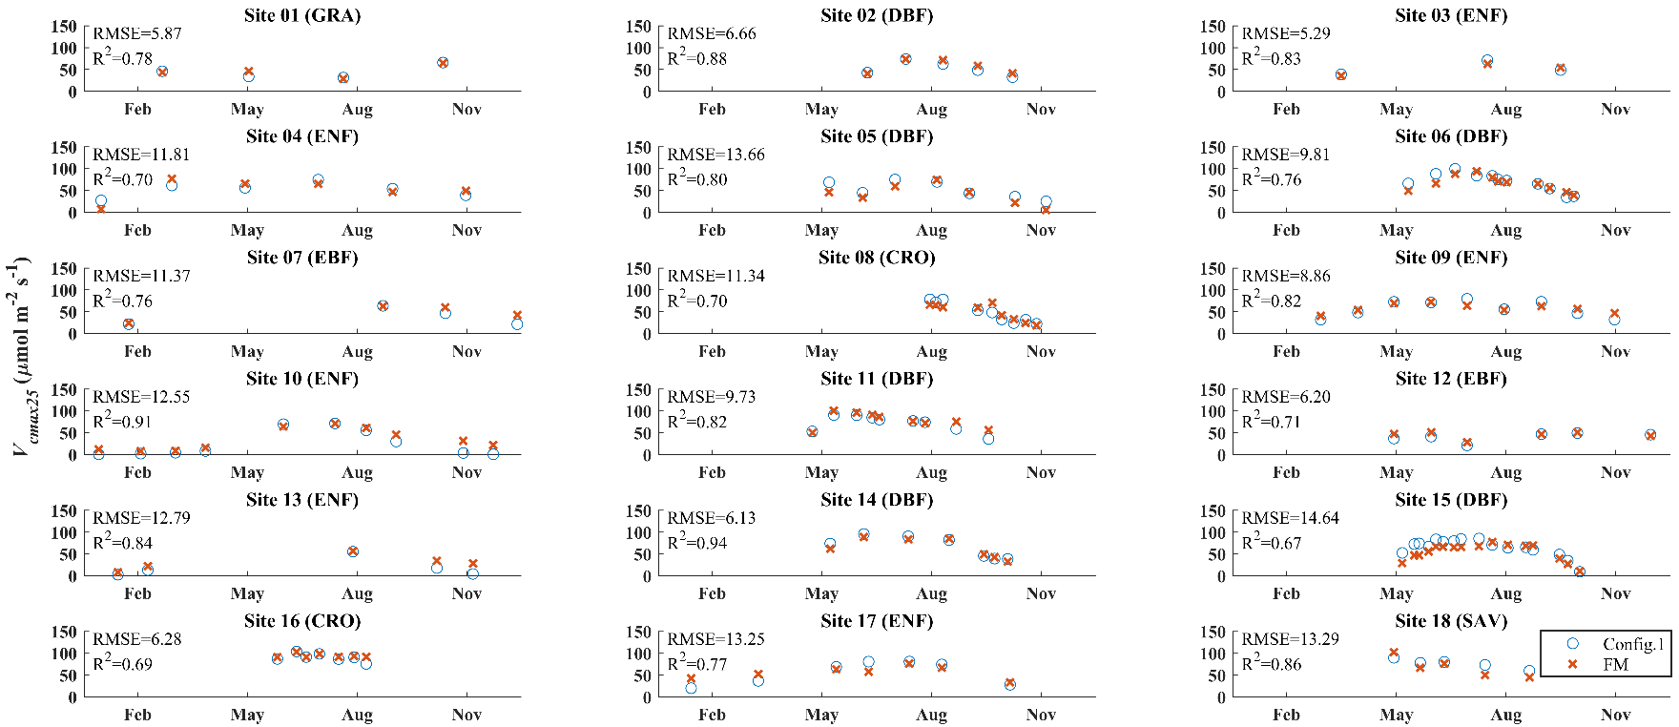

**Fig. 1.** Comparison between simulated *Vcmax25* (μmol·m-2·s-1) of Scheme 1 (LCC-based leaf absorptance and field-measured *rJV25*) and field measurements over the growing season at 18 sites. FM indicates field-measured *Vcmax25*.

The scatterplots between field-measured *Vcmax25* and simulated *Vcmax25* of Schemes 1 to 6 are shown in Fig. 2. Scheme 1 had the best agreement with field measurements among 6 schemes with a R2 of 0.80 and RMSE of 11.57 μmol·m-2·s-1, demonstrating the robust performance of the model. Schemes 2 (fixed leaf absorptance and field-measured *rJV25*) and 3 (LCC-based leaf absorptance and fixed *rJV25*) both agreed worse with field measurements than Scheme 1. Scheme 2 overestimated *Vcmax25* at low values but underestimated *Vcmax25* at high values. The worse agreement suggested that the variations in leaf absorptance and fixed *rJV25* should be considered in the optimality-based model. Scheme 4 (LCC-based leaf absorptance and *Tg*-based *rJV25*) had the second-best agreement with field-measured *Vcmax25* in Fig. 2, reducing about 20% of the RMSE compared to Scheme 3. Although Scheme 4 had worse model performance than Scheme 1, R2 was still high (0.76), and the regression line was close to the 1:1 line. The good performance of Scheme 4 indicated that using the empirical relationship to estimate *rJV25* from *Tg* was reliable at the 18 sites. Scheme 5 (fixed leaf absorptance and *Tg*-based *rJV25*) showed worse agreement with field measurements than Scheme 4, suggesting the necessity to incorporate variations in leaf absorptance into the optimality-based model again. Scheme 6 (variations in leaf absorptance and *rJV25* were not incorporated to constrain the model) agreed worst with field-measured *Vcmax25*, indicating that the variations in *Vcmax25* acclimated to the environment was not fully explained by the optimality-based model without incorporating variations in leaf absorptance and *rJV25* to constrain the model.

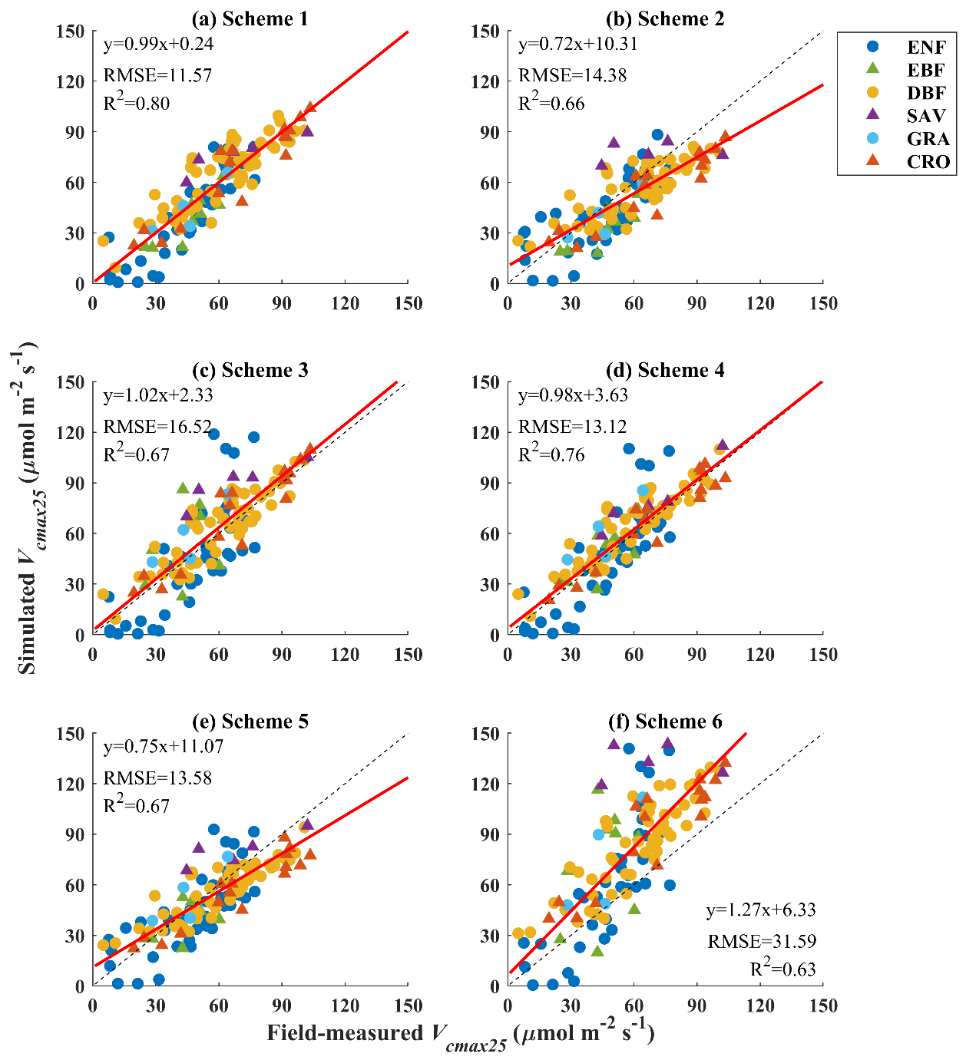

**Fig. 2.** Comparisons between all field measurements and simulated *Vcmax25* of **(a)** Scheme 1, **(b)** Scheme 2 (fixed leaf absorptance and field-measured *rJV25*), **(c)** Scheme 3 (LCC-based leaf absorptance and fixed *rJV25*), **(d)** Scheme 4 (LCC-based leaf absorptance and *Tg*-based *rJV25*), **(e)** Scheme 5 (fixed leaf absorptance and *Tg*-based *rJV25*), and **(f)** Scheme 6 (variations in leaf absorptance and *rJV25* were not incorporated to constrain the model) over the growing season at 18 sites. The red lines are the regression lines, and the black dash lines are the 1:1 lines.

### 3.2 Effects of LCC and environmental conditions on *Vcmax25* at the site level

Fig. 3ato 3c demonstrates how *B*, the difference between simulated *Vcmax25* with dynamic leaf absorptance (Scheme 1) and that with fixed leaf absorptance (Scheme 2) relative to field measurements, varied with environmental conditions at 18 sites. *B* positively correlated with *I*, *T*, and *Dg*, indicating that Scheme 1 tended to be lower than Scheme 2 when the environment was darker, colder, and wetter while higher in the opposite environment. *B* was lower than -100% when *T* is under 0 °C, which was set as the threshold to define the growing season in this study since plants might be hard to photosynthesize with frozen tissues under negative *T*, suggesting that estimating leaf absorptance from LCC enabled the optimality-based model to track *Vcmax25* under unfavorable environment for plant growth. After removing these data with negative *T*, *B* still positively correlated with *I*, *T*, and *Dg* (Fig. 3eto 3g). *B* was affected more by *I* and *T* with higher r values, while *Dg* exerted weak influences on *B*. Regardless of removing data with *T* under 0 °C, *B* positively correlated with field-measured *Vcmax25*, suggesting that the optimality-based model performed better in capturing the high and low values of *Vcmax25* during the growing season after incorporating variations in leaf absorptance. MODIS LCC, the input to estimate leaf absorptance, positively correlated with *I*, *T*, and field-measured *Vcmax25* while showing no relationship with *Dg* (Fig. 3ito 3l). How field-measured *Vcmax25* was affected by environmental conditions is demonstrated in Fig. 3m-3o. *I*, *T*, and *Dg* all positively correlated with field-measured *Vcmax25*. Among these three environmental factors, *I* was the most dominating one in controlling *Vcmax25*. APAR, the product of *I* and , correlated even better with field-measured *Vcmax25* than *I* (Fig. 3p), suggesting that the seasonal variation in leaf absorptance also contributed to the seasonal variation in *Vcmax25* other than the dominated driver *I*.

**Fig. 3.** The first row shows relationships between *B* (; %) and **(a)** *I* (incoming photosynthetic photon flux density; μmol·m-2·s-1), **(b)** *T* (air temperature; °C), **(c)** *Dg* (vapor pressure deficit; Pa), and **(d)** field-measured *Vcmax25* at 18 sites. **(e)** to **(h)** are the same as **(a)** to **(d)** but removing data with *T* lower than 0 °C. The third row shows relationships between MODIS LCC (μg·cm-2) and **(i)** *I*, **(j)** *T*, **(k)** *Dg*, and **(l)** field-measured *Vcmax25* at 18 sites. The fourth row shows relationships between field-measured *Vcmax25* and **(m)** *I*, **(n)** *T*, **(o)** *Dg*, and **(p)** APAR (absorbed photosynthetic photon flux density; μmol·m-2·s-1) at 18 sites. The red lines are the regression lines.

### 3.3 The global variation in simulated *Vcmax25* and the effect of leaf absorptance and *rJV25*

The global distribution of RS-*rJV25* is shown in Fig. 4a with a latitudinal pattern that RS-*rJV25* generally increased with latitude. In contrast, *Tg* generally decreased with latitude (Fig. 4b). Strong negative correlation was observed between RS-*rJV25* and *Tg* latitudinally with a r value of -0.95. We compared three empirical relationships between *rJV25* and *Tg* (Fig. 4c). The RS-empirical relationship was similar to the Obs-empirical relationship, while they both agreed with the Ref-empirical relationship at high *Tg* but had steeper slopes than the Ref-empirical relationship at low *Tg*.

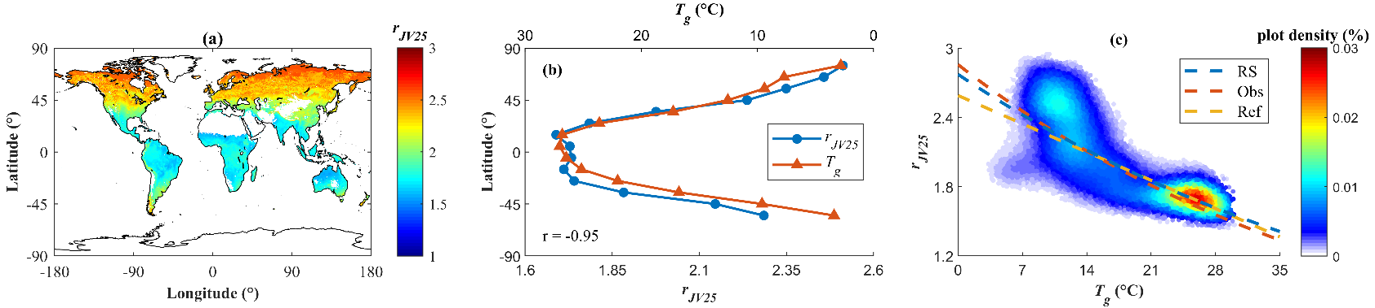

**Fig. 4. (a)** Global distribution of RS-*rJV25*; **(b)** Latitudinal variations in RS-*rJV25* and *Tg* (mean air temperature over the growing season; °C); **(c)** Relationships between RS-*rJV25* and *Tg* for all pixels on the global map. The blue, red, and yellow dash lines in **(c)** are empirical relationships between *rJV25* and *Tg* based on the remote sensing method (RS-empirical relationship), derived from a global observational dataset in Smith et al. (2019) (Obs-empirical relationship), and established in Kattge & Knorr (2007) (Ref-empirical relationship), respectively.

The global distributions of simulated *Vcmax25* of Scheme 4 (LCC-based leaf absorptance and *Tg*-based *rJV25*) are shown in Fig. 5a, 5d, and 5g, respectively, at DOY 9 (the beginning of January), 97 (the beginning of April), and 185 (the beginning of July). An increasing trend of simulated *Vcmax25* was shown at high latitudes of the Northern Hemisphere at these three dates, while a decreasing trend was shown at high latitudes of the Southern Hemisphere. The temporal variations in simulated *Vcmax25* were more minor at low latitudes than at high latitudes, especially for EBF in the equatorial region. Global distributions of the difference between simulated *Vcmax25* with dynamic leaf absorptance and that with fixed leaf absorptance (difference between Schemes 4 and 5; Δ*Vcmax25*) relative to Scheme 4 are shown in Fig. 5b, 5e, and 5h at the three dates, respectively. Scheme 4 was always higher than Scheme 5 in areas maintaining high LCC and hence leaf absorptance over the growing season, such as EBF in the equatorial region, and it was always lower than Scheme 5 in areas with sparse vegetation cover, such as SHR and GRA in the southern regions of South America. In other areas, Scheme 5 tended to overestimate in winter and underestimate in summer compared to Scheme 4, implying that seasonal variations in leaf absorptance contributed to high *Vcmax25* in summer and low *Vcmax25* in winter. The sensitivity analyses of Δ*Vcmax25* on are shown in Fig. 5c, 5f, and 5i at the three dates, respectively. Δ*Vcmax25* generally increased with , while the slope, i.e., the increasing rate, differed in different latitudes at different phases of the growing season. Values of *I*, *Dg*, and *rJV25* for different regions and DOY used in the sensitivity analysis are shown in Fig. S3. According to Fig. S3, the slope of Δ*Vcmax25* to Δ (75%) was dominated by *I*, meaning that simulated *Vcmax25* was more sensitive to variations in LCC under higher irradiance, while *Dg* and *rJV25* exerted minor influences on the slope. Under similar *I*, the slope increased with *Dg* and *rJV25*. Similar patterns in Fig. 5a to 5c and 5d to 5f were observed at DOY 361 (the end of December) and 273 (the end of September), respectively (Fig. S2).

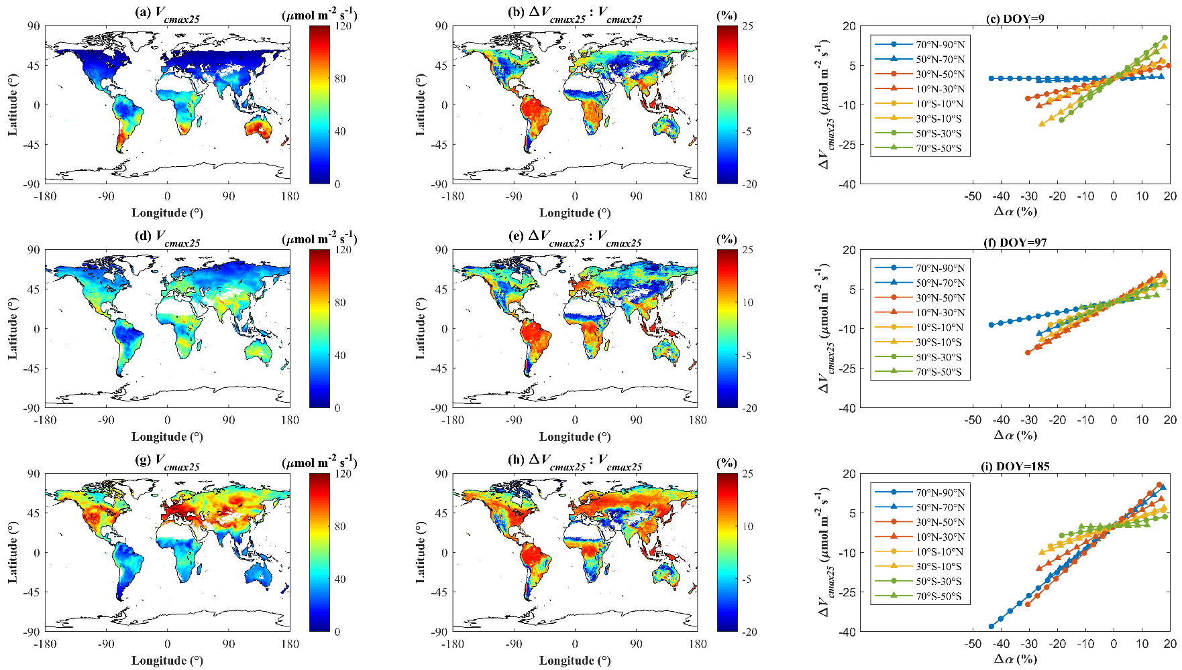

**Fig. 5. (a)** , **(d)**,and **(g)** Global distributions of simulated *Vcmax25* of Scheme 4 at DOY (day of the year) 9, 97 and 185, respectively; **(b)**, **(e)**, and **(h)** Global distributions of the difference between Schemes 4 and 5 relative to Scheme 4 (; %) at DOY 9, 97 and 185, respectively. Δ*Vcmax25* represents the difference between Scheme 4 and 5; **(c)**, **(f)**, and **(i)** Sensitivity of Δ*Vcmax25* to variations in in different regions at DOY 9, 97 and 185, respectively. The global mapsonly show areas with positive estimates, while the other areas are in blank.

The seasonal variations in Scheme 4 among different PFTs and latitudinal regions are demonstrated in Fig. 6. Opposite trends were shown in the Northern and Southern Hemispheres over a year (Fig. 6a and 6b). EBF had the smallest variations and maxima in Scheme 4 over the growing season compared to the other biomes. Except for EBF, the other biomes showed similar seasonal variations in Scheme 4, which were high in the summer and low in the winter. In these biomes, forests had the biggest maxima over the growing season, seconded by CRO and GRA, while SHR and SAV showed the smallest maxima. However, the difference in these maxima were relatively small. Seasonal variations in Scheme 4 were more diverse among different latitudinal regions than different PFTs (Fig. 6c), implying that the environment exerted greater influences on the variations in *Vcmax25* than the biome distribution. The equatorial regions showed minor seasonal variations in Scheme 4 with the smallest maxima. Although the seasonal trends in Scheme 4 were opposite in the Northern and Southern Hemispheres over a year, it was similar that high latitudes had smaller maxima than mid-latitudes.

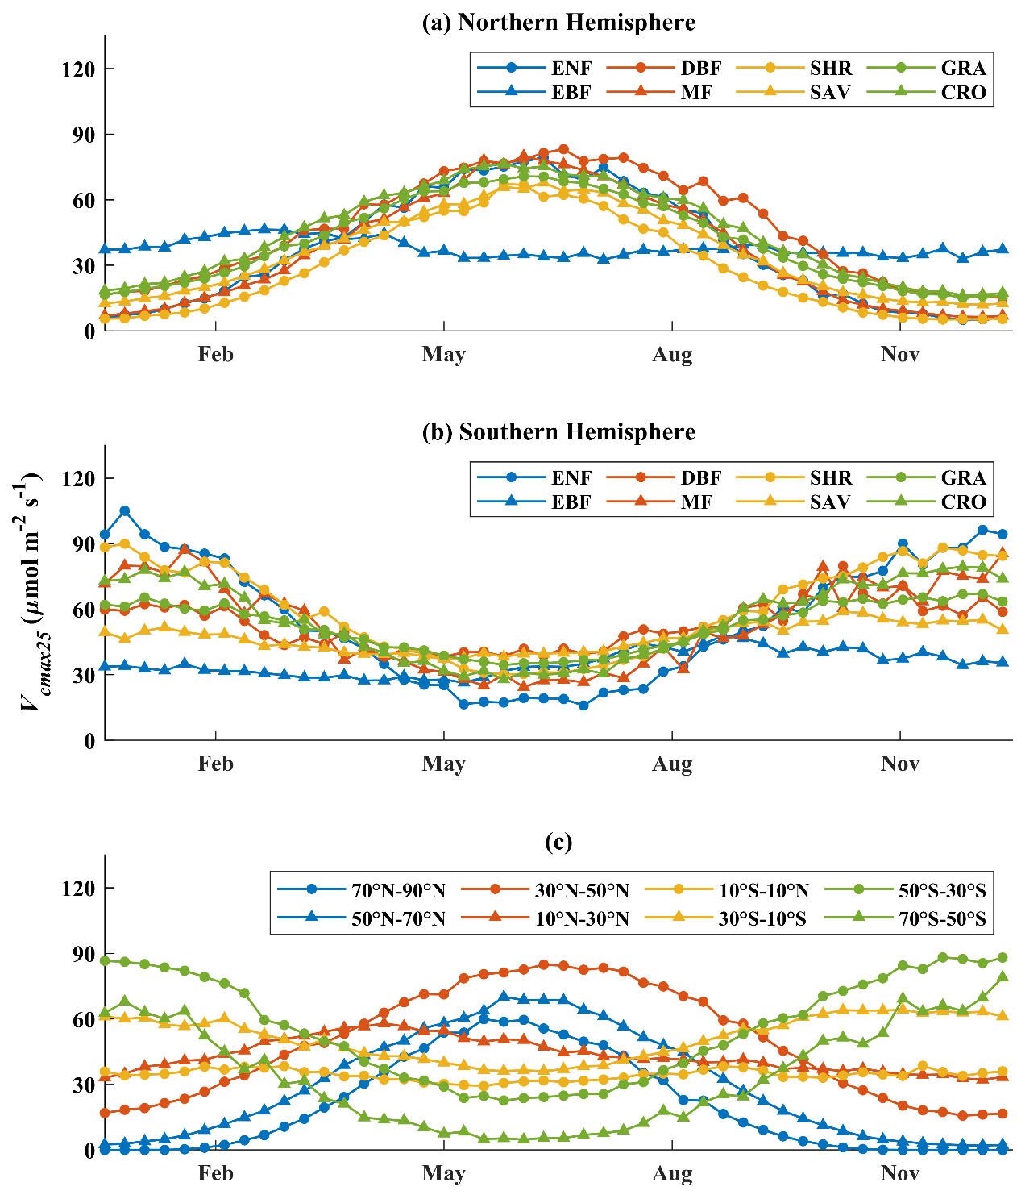

**Fig. 6.** Seasonal variations in simulated *Vcmax25* of Scheme 4 for different **(a)** PFTs in the Northern Hemisphere; **(b)** PFTs in the Southern Hemisphere; **(c)** latitudinal regions.

## 4 Discussion

### 4.1 The constraint of photosynthetic nitrogen other than RuBisCO on *Vcmax25*

The photosynthetic nitrogen, i.e., nitrogen used to build proteins of photosynthetic apparatus, provides the foundation for three major photosynthetic processes: light harvesting, electron transport, and carboxylation (Evans, 1989). Altering the investment of photosynthetic nitrogen in different photosynthetic processes helps plants acclimate to the environment (Evans & Poorter, 2001; Hikosaka et al., 2006; Kattge & Knorr, 2007; Leakey et al., 2009; Rogers et al., 2017b). By proposing a ‘strong’ form of the coordination theory assuming that plants preferentially allocate photosynthetic nitrogen to balance the carboxylation and electron transport rates under given light availability, the photosynthetic nitrogen demand for RuBisCO was found to be driven by the environment through acclimation (Smith et al., 2019). Our results supported this finding and further suggested that variations in *Vcmax25* cannot be fully captured by the environmental factors alone because of the constraint of photosynthetic nitrogen other than RuBisCO on *Vcmax25*.

Leaves with different LCC absorb different numbers of photons under the same irradiance level, explaining why MODIS LCC positively correlated to field-measured *Vcmax25* at 18 sites and field-measured *Vcmax25* correlated to APAR better than *I* (Fig. 3). With a fixed leaf absorptance over the growing season, simulated *Vcmax25* tended to be overestimated at the beginning and the end of the growing season but underestimated during the growing season peak. After incorporating dynamic leaf absorptance, the optimality-based model captured seasonal variations in field-measured *Vcmax25* more accurately. These results suggested that seasonal variations in leaf absorptance, which is driven by LCC, contributed to seasonal variations in *Vcmax25*. According to our model, LCC controlled leaf absorptance, whose variations resulted in variations in electron transport and led to the adjustment of *Vcmax25* to balance carboxylation and electron transport. Therefore, light availability of the environment determined the maximum electron transport and hence carboxylation, while the actual electron transport rate was also constrained by photosynthetic nitrogen related to light harvesting, which can be parameterized by leaf absorptance with consideration of LCC. The variations in photosynthetic nitrogen related to light harvesting made the influence of irradiance level on *Vcmax25* vary spatially and temporally. The relationship between leaf absorptance and *Vcmax25* was influenced by *I*, *Dg*, and *rJV25*. Our global analyses (Figs. 5 and S1) showed that *I* mainly determined how much the variation in leaf absorptance influenced the variation in *Vcmax25*. *Vcmax25* had minor variations under low irradiance even though leaf absorptance varied considerably, while small variations in leaf absorptance led to dramatic variations in *Vcmax25* under high irradiance. Higher *Dg* and *rJV25* also contributed to the greater influence of leaf absorptance on *Vcmax25* but with minor contributions compared to *I*.

Regulation of the partitioning of photosynthetic nitrogen between electron transport and carboxylation, reflected by *rJV25*, has been considered as an essential mechanism for plants to achieve the maximal carbon assimilation rate under the given environmental condition (Chen et al., 1993; Rogers et al., 2017b; Walker et al., 2014). Theoretically, high *rJV25* alleviates the limitation of RuBP regeneration on CO2 assimilation, while low *rJV25* mitigates the limitation of RuBisCO capacity on CO2 assimilation under a given environment (Eq. 1). The accuracy of simulated *Vcmax25* was greatly reduced after using fixed *rJV25* instead of field measurements (Fig. 2), which varied considerably at the 18 sites (Table 1), or *rJV25* estimated from *Tg*. The results indicated that the photosynthetic nitrogen demand for RuBisCO was affected by the adjusted balance between carboxylation and electron transport through acclimating to the environment. Estimating *rJV25* in advance enabled the optimality-based model to incorporate the acclimated balance to constrain the simulation, thus improving accuracy. We found that RS-*rJV25* and *Tg* had opposite latitudinal distribution patterns on the global scale, and the strong negative correlations between them indicated that *rJV25* varied with *Tg*. Therefore, lower *Tg* caused higher *rJV25* and *Vcmax25* with more photosynthetic nitrogen demand for RuBisCO when the other environmental conditions were similar, and vice versa. In addition to the first-order driver *I*, the effect of *Tg* on adjusting the balance between carboxylation and electron transport also influenced the latitudinal distribution pattern of *Vcmax25*, making *Vcmax25* higher at some higher latitudes even though with lower *I* and *Dg*.

In sum, although carboxylation matched with electron transport under average environmental conditions through acclimation, variations in photosynthetic nitrogen related to light harvesting and electron transport adjusted the balance between carboxylation and electron transport, constraining how the environment drove the photosynthetic nitrogen demand for RuBisCO. The considerable variations in leaf absorptance and *rJV25* indicated that the response of *Vcmax25* to environmental drivers varied spatially and temporally. Variations in *Vcmax25* were therefore simulated more accurately by the optimality-based model after we constrained it by incorporating the parameterization of photosynthetic nitrogen information related to light harvesting and electron transport, i.e., leaf absorptance and *rJV25*.

### 4.2 Global parameterization of leaf absorptance and *rJV25* based on remote sensing data

With the recent advances in LCC retrieval algorithms, global LCC datasets are available based on remote sensing methods with reasonable estimates. Leaf absorptance can then be easily estimated from LCC on the global scale using the PROSPECT model, which has been widely used and validated (Croft et al., 2015; Darvishzadeh et al., 2008; Demarez and Gastellu-Etchegorry, 2000; Malenovský et al., 2006). Incorporating the estimated leaf absorptance improved the accuracy of simulated *Vcmax25*, showing that the contribution of seasonal variations in leaf absorptanceto that in *Vcmax25* can be reasonably captured using our parametrization method. Compared to using LCC to estimate leaf absorptance for *Vcmax25* modelling, LCC was normally used to estimate *Vcmax25* directly based on empirical relationships between LCC and *Vcmax25*. Although LCC often showed good correlations with *Vcmax25* (Chou et al., 2020; Croft et al., 2017; Houborg et al., 2013, 2015; Lu et al., 2022; Qian et al., 2021; Wang et al., 2020), a universal relationship between LCC and *Vcmax25* have not been found. Our results showed that LCC was not the most determining driver of *Vcmax25*, and the influence of LCC, i.e., leaf absorptance, on *Vcmax25* was controlled by the environment. Therefore, it is better to incorporate the environmental effects into the empirical relationships rather than estimating *Vcmax25* from LCC alone. Since canopy-average APAR is easy to be estimated from LAI data, some previous versions of the optimality-based model simulated canopy-average leaf-level *Vcmax25* (Dong et al., 2023) or converted the canopy-average leaf-level *Vcmax25* to the top-leaf *Vcmax25* based on a nitrogen vertical distribution coefficient (Jiang et al., 2020). We adopted the method in Jiang et al. (2020) to estimate canopy-average APAR and the nitrogen vertical distribution coefficient. Then, the derived estimates were substituted into Eq. 14 to simulate canopy-average leaf-level *Vcmax25* and top-leaf *Vcmax25*, respectively. The results were compared to Scheme 1 at the 18 sites to evaluate whether using the top-leaf APAR estimated from LCC to parameterize the optimality-based model outperforms the other parameterization methods. The results showed that field measurements agreed with simulations using LCC-based top-leaf APAR (Fig. S4a) better than canopy-average APAR (Fig. S4b). Under a given irradiance level, the top-leaf APAR is determined by leaf absorptance and hence LCC, while canopy-average APAR also varies with the canopy depth. Because field measurements at the 18 sites were made on leaves at the top of the sunlit canopy, which were rarely affected by the canopy depth, the top-leaf APAR related to the photosynthetic processes of these leaves better than the canopy-average APAR. With the increase of LAI, i.e., the canopy depth, the sunlit portion of the canopy reaches its maximum while the shaded portion still increases. Since the irradiance level at the shaded canopy is much lower than at the sunlit canopy, the top-leaf APAR is much higher than the canopy-average APAR at large LAI, making the simulated *Vcmax25* based on canopy-average APAR be underestimated at high field-measured *Vcmax25*. The underestimation was alleviated after converting the canopy-average leaf-level *Vcmax25* to the top-leaf *Vcmax25* using the nitrogen vertical distribution coefficient, but the simulations based on Eq. 14 (Fig. S4c) and the model formulation in Jiang et al. (2020) (Fig. S4d) still both agreed worse with field measurements than Scheme 1. Although the model performance was good in Jiang et al. (2020) at 10 sites, only 6 of the 10 sites met the selection criteria of this study and were included in the validation dataset with the other 12 sites. The nitrogen vertical distribution coefficient has not been estimated and tested at large scales, and it was empirically estimated from LAI at the 10 sites in Jiang et al. (2020). Our results indicated that this empirical relationship might not be valid at other sites, limiting the application of this parameterization method to large scales. As TBMs often adopted the top-leaf *Vcmax25* as input to estimate photosynthesis at the leaf level and then converted the leaf-level estimates to the canopy level using some canopy scaling methods (Bonan et al., 2011; Chen et al., 1999; Clark et al., 2011; Knorr, 2000; Krinner et al., 2005; Medvigy et al., 2009; Sellers et al., 1996), parameterizing leaf absorptance from LCC to simulate *Vcmax25* could serve the purpose of improving carbon modelling better than other parametrization methods.

Although *rJV* can be predicted by previous versions of the optimality-based model (Smith et al., 2020), we estimated *rJV25* in advance and used it to constrain the simulated *Vcmax25* (Eq. 14). To evaluate whether predicting *rJV25* in advance improves the model performance, we simulated *Vcmax25* using the model version in Smith et al. (2019), Jiang et al. (2020), and Peng et al. (2021) using the same input data as Scheme 1 and compared the simulations with Scheme 1 at the 18 sites. The only difference between Scheme 1 and the other versions was that Scheme 1 adopted field-measured *rJV25* to constrain *Vcmax25*, while the other three versions had no requirement to estimate *rJV25* in advance. Scheme 1 performed better than the other three versions (Fig. S5), suggesting that *Vcmax25* can be simulated by the optimality-based model more accurately after parameterizing *rJV25* reasonably and incorporating it to constrain the model. To parameterize *rJV25* globally, we did not estimate *rJV25* from *Tg* using the empirical relationships established in past literature but estimated *rJV25* from RS-*rJV25* by establishing the empirical relationship between *Tg* and RS-*rJV25*. Compared to field measurements, RS-*rJV25* can demonstrate the global distribution pattern of *rJV25* and be compared with *Tg* globally, so it is useful for global modelling. Our results indicated that *rJV25* estimated from *Tg* was overall reliable for *Vcmax25* modelling, as Scheme 4 captured 76% of variations in field-measured *Vcmax25* at 18 sites. The RS-empirical relationship agreed with the Obs-empirical relationship and the Ref-empirical relationship at high *Tg*, while the Ref-empirical relationship estimated a lower *rJV25* than the other two empirical relationships at low *Tg*. The disagreement may be because the Ref-empirical relationship was established in Kattge & Knorr (2007) based on field measurements of 36 species that did not include boreal species with *Tg* under 10 °C. Rogers et al. (2017b) found that boreal species with low *Tg* have higher *rJV25* to maintain carbon assimilation under lower irradiance levels, and the field-measured *rJV25* agreed with the values estimated from the RS-empirical relationship and the Obs-empirical relationship, which had better representativeness of boreal species with low *Tg* than the Ref-empirical relationship. As mechanistic models of *rJV25* or widely adopted global *rJV25* datasets are not yet available, the empirical *rJV25* presented in this study is a good alternative in the current stage to be used in the optimality-based model on the global scale.

### 4.3 Implications for the global terrestrial biosphere and leaf trait modelling

After estimating leaf absorptance and *rJV25* globally based on remote sensing data, we were able to incorporate the variations in these two parameters into the optimality-based model to constrain the acclimation of *Vcmax25* to the environment. The model with parametrized leaf absorptance and *rJV25* considerably improved its accuracy in simulating *Vcmax25* over the growing season. These results supported our hypotheses that variations in leaf absorptance and *rJV25*, which contain information on photosynthetic nitrogen related to the three major photosynthetic processes, contribute to variations in the photosynthetic nitrogen demand for RuBisCO and hence *Vcmax25* that have not been fully captured by the optimality-based model. We demonstrated considerable spatial and temporal variations in simulated *Vcmax25* on the global scale, and the results indicated that the spatiotemporal distribution patterns of *Vcmax25* were mainly controlled by the distribution patterns of the environmental drivers rather than those of the biomes. As all the inputs are from open-source datasets, the model can easily be applied to large areas to simulate reliable seasonal variations in *Vcmax25*, which can be an essential step to improve the global terrestrial ecosystem and leaf trait modelling that requires *Vcmax25* as input.

## Appendix. Supplementary Material

## References

Alton, P. B. (2018). Decadal trends in photosynthetic capacity and leaf area index inferred from satellite remote sensing for global vegetation types. *Agricultural and Forest Meteorology*, *250*, 361-375.

Arellano, P., Tansey, K., Balzter, H., & Boyd, D. S. (2017a). Field spectroscopy and radiative transfer modelling to assess impacts of petroleum pollution on biophysical and biochemical parameters of the Amazon rainforest. *Environmental Earth Sciences*, *76*, 1-14.

Arellano, P., Tansey, K., Balzter, H., & Tellkamp, M. (2017b). Plant family-specific impacts of petroleum pollution on biodiversity and leaf chlorophyll content in the Amazon rainforest of Ecuador. *PloS one*, *12*(1), e0169867.

Bahar, N. H., Ishida, F. Y., Weerasinghe, L. K., Guerrieri, R., O'Sullivan, O. S., Bloomfield, K. J., ... & Atkin, O. K. (2017). Leaf‐level photosynthetic capacity in lowland Amazonian and high‐elevation Andean tropical moist forests of Peru. *New Phytologist*, *214*(3), 1002-1018.

Bernacchi, C. J., Pimentel, C., & Long, S. P. (2003). In vivo temperature response functions of parameters required to model RuBP‐limited photosynthesis. *Plant, Cell & Environment*, *26*(9), 1419-1430.

Bernacchi, C. J., Morgan, P. B., Ort, D. R., & Long, S. P. (2005). The growth of soybean under free air [CO 2] enrichment (FACE) stimulates photosynthesis while decreasing in vivo Rubisco capacity. *Planta*, *220*, 434-446.

Bigras, F. J., & Bertrand, A. (2006). Responses of Picea mariana to elevated CO2 concentration during growth, cold hardening and dehardening: phenology, cold tolerance, photosynthesis and growth. *Tree Physiology*, *26*(7), 875-888.

Bonan, G. B., Lawrence, P. J., Oleson, K. W., Levis, S., Jung, M., Reichstein, M., ... & Swenson, S. C. (2011). Improving canopy processes in the Community Land Model version 4 (CLM4) using global flux fields empirically inferred from FLUXNET data. *Journal of Geophysical Research: Biogeosciences*, *116*(G2).

Carswell, F. E., Meir, P., Wandelli, E. V., Bonates, L. C. M., Kruijt, B., Barbosa, E. M., ... & Jarvis, P. G. (2000). Photosynthetic capacity in a central Amazonian rain forest. *Tree physiology*, *20*(3), 179-186.

Chen, J. L., Reynolds, J. F., Harley, P. C., & Tenhunen, J. D. (1993). Coordination theory of leaf nitrogen distribution in a canopy. *Oecologia*, *93*, 63-69.

Chen, J. M., Liu, J., Cihlar, J., & Goulden, M. L. (1999). Daily canopy photosynthesis model through temporal and spatial scaling for remote sensing applications. *Ecological modelling*, *124*(2-3), 99-119.

Chen, J. M., Wang, R., Liu, Y., He, L., Croft, H., Luo, X., ... & Dong, N. (2022). Global datasets of leaf photosynthetic capacity for ecological and earth system research. *Earth System Science Data*, *14*(9), 4077-4093.

Clark, D. B., Mercado, L. M., Sitch, S., Jones, C. D., Gedney, N., Best, M. J., ... & Cox, P. M. (2011). The Joint UK Land Environment Simulator (JULES), model description–Part 2: carbon fluxes and vegetation dynamics. *Geoscientific Model Development*, *4*(3), 701-722.

Chou, S., Chen, B., Chen, J., Wang, M., Wang, S., Croft, H., & Shi, Q. (2020). Estimation of leaf photosynthetic capacity from the photochemical reflectance index and leaf pigments. *Ecological Indicators*, *110*, 105867.

Croft, H., Chen, J. M., Zhang, Y., Simic, A., Noland, T. L., Nesbitt, N., & Arabian, J. (2015). Evaluating leaf chlorophyll content prediction from multispectral remote sensing data within a physically-based modelling framework. *ISPRS Journal of Photogrammetry and Remote Sensing*, *102*, 85-95.

Croft, H., Chen, J. M., Luo, X., Bartlett, P., Chen, B., & Staebler, R. M. (2017). Leaf chlorophyll content as a proxy for leaf photosynthetic capacity. *Global change biology*, *23*(9), 3513-3524.

Croft, H., Chen, J. M., Wang, R., Mo, G., Luo, S., Luo, X., ... & Bonal, D. (2020). The global distribution of leaf chlorophyll content. *Remote Sensing of Environment*, *236*, 111479.

Dalmagro, H. J., de Lobo, F. A., Vourlitis, G. L., Dalmolin, Â. C., Antunes Jr, M. Z., Ortíz, C. E. R., & Nogueira, J. D. S. (2013). Photosynthetic parameters of two invasive tree species of the Brazilian Pantanal in response to seasonal flooding. *Photosynthetica*, *51*(2), 281-294.

Darvishzadeh, R., Skidmore, A., Schlerf, M., & Atzberger, C. (2008). Inversion of a radiative transfer model for estimating vegetation LAI and chlorophyll in a heterogeneous grassland. *Remote sensing of environment*, *112*(5), 2592-2604.

De Kauwe, M. G., Lin, Y. S., Wright, I. J., Medlyn, B. E., Crous, K. Y., Ellsworth, D. S., ... & Domingues, T. F. (2016). A test of the ‘one‐point method’for estimating maximum carboxylation capacity from field‐measured, light‐saturated photosynthesis. *New Phytologist*, *210*(3), 1130-1144.

de la Riva, E. G., Olmo, M., Poorter, H., Ubera, J. L., & Villar, R. (2016). Leaf mass per area (LMA) and its relationship with leaf structure and anatomy in 34 Mediterranean woody species along a water availability gradient. *PloS one*, *11*(2), e0148788.

Demarez, V., & Gastellu-Etchegorry, J. P. (2000). A modeling approach for studying forest chlorophyll content. *Remote Sensing of Environment*, *71*(2), 226-238.

De Santis, A., Chuvieco, E., & Vaughan, P. J. (2009). Short-term assessment of burn severity using the inversion of PROSPECT and GeoSail models. *Remote Sensing of Environment*, *113*(1), 126-136.

Dillen, S. Y., de Beeck, M. O., Hufkens, K., Buonanduci, M., & Phillips, N. G. (2012). Seasonal patterns of foliar reflectance in relation to photosynthetic capacity and color index in two co-occurring tree species, Quercus rubra and Betula papyrifera. *Agricultural and Forest Meteorology*, *160*, 60-68.

Domingues, T. F., Meir, P., Feldpausch, T. R., Saiz, G., Veenendaal, E. M., Schrodt, F., ... & Lloyd, J. O. N. (2010). Co‐limitation of photosynthetic capacity by nitrogen and phosphorus in West Africa woodlands. *Plant, Cell & Environment*, *33*(6), 959-980.

Dong, N., Wright, I. J., Chen, J. M., Luo, X., Wang, H., Keenan, T. F., ... & Prentice, I. C. (2022). Rising CO2 and warming reduce global canopy demand for nitrogen. *New Phytologist*, *235*(5), 1692-1700.

Dong, N., Dechant, B., Wang, H., Wright, I. J., & Prentice, I. C. (2023). Global leaf‐trait mapping based on optimality theory. *Global Ecology and Biogeography*.

Ellsworth, D. & Crous, K. (2016). A global dataset of photosynthetic CO2 response curves measured in the field at controlled light, CO2 and temperatures. Univ.West. Sydney, https://doi.org/10.4225/35/569434cfba16e

Evans, J. R. (1989). Photosynthesis and nitrogen relationships in leaves of C3 plants. *Oecologia*, *78*(1), 9-19.

Evans, J. R., & Seemann, J. R. (1989). The allocation of protein nitrogen in the photosynthetic apparatus: costs, consequences, and control. *Photosynthesis*, *8*, 183-205.

Evans, J., & Poorter, H. (2001). Photosynthetic acclimation of plants to growth irradiance: the relative importance of specific leaf area and nitrogen partitioning in maximizing carbon gain. *Plant, cell & environment*, *24*(8), 755-767.

Farquhar, G. D., von Caemmerer, S. V., & Berry, J. A. (1980). A biochemical model of photosynthetic CO 2 assimilation in leaves of C 3 species. *planta*, *149*, 78-90.

Feret, J. B., François, C., Asner, G. P., Gitelson, A. A., Martin, R. E., Bidel, L. P., ... & Jacquemoud, S. (2008). PROSPECT-4 and 5: Advances in the leaf optical properties model separating photosynthetic pigments. *Remote sensing of environment*, *112*(6), 3030-3043.

Feret, J. B., François, C., Gitelson, A., Asner, G. P., Barry, K. M., Panigada, C., ... & Jacquemoud, S. (2011). Optimizing spectral indices and chemometric analysis of leaf chemical properties using radiative transfer modeling. *Remote sensing of environment*, *115*(10), 2742-2750.

Frankenberg, C., Fisher, J. B., Worden, J., Badgley, G., Saatchi, S. S., Lee, J. E., ... & Yokota, T. (2011). New global observations of the terrestrial carbon cycle from GOSAT: Patterns of plant fluorescence with gross primary productivity. Geophysical Research Letters, 38(17).

Friedl, M. A., McIver, D. K., Hodges, J. C., Zhang, X. Y., Muchoney, D., Strahler, A. H., ... & Schaaf, C. (2002). Global land cover mapping from MODIS: algorithms and early results. *Remote sensing of Environment*, *83*(1-2), 287-302.

Friedlingstein, P., O'sullivan, M., Jones, M. W., Andrew, R. M., Gregor, L., Hauck, J., ... & Zheng, B. (2022). Global carbon budget 2022. Earth System Science Data Discussions, 2022, 1-159.

Gelaro, R., McCarty, W., Suárez, M. J., Todling, R., Molod, A., Takacs, L., ... & Zhao, B. (2017). The modern-era retrospective analysis for research and applications, version 2 (MERRA-2). *Journal of climate*, *30*(14), 5419-5454.

Grassi, G., Vicinelli, E., Ponti, F., Cantoni, L., & Magnani, F. (2005). Seasonal and interannual variability of photosynthetic capacity in relation to leaf nitrogen in a deciduous forest plantation in northern Italy. *Tree Physiology*, *25*(3), 349-360.

Guanter, L., Frankenberg, C., Dudhia, A., Lewis, P. E., Gómez-Dans, J., Kuze, A., ... & Grainger, R. G. (2012). Retrieval and global assessment of terrestrial chlorophyll fluorescence from GOSAT space measurements. Remote Sensing of Environment, 121, 236-251.

Han, Q., Kawasaki, T., Nakano, T., & Chiba, Y. (2004). Spatial and seasonal variability of temperature responses of biochemical photosynthesis parameters and leaf nitrogen content within a Pinus densiflora crown. *Tree physiology*, *24*(7), 737-744.

He, L., Chen, J. M., Liu, J., Zheng, T., Wang, R., Joiner, J., ... & Rogers, C. (2019). Diverse photosynthetic capacity of global ecosystems mapped by satellite chlorophyll fluorescence measurements. *Remote Sensing of Environment*, *232*, 111344.

Hikosaka, K., & Terashima, I. (1996). Nitrogen partitioning among photosynthetic components and its consequence in sun and shade plants. *Functional Ecology*, 335-343.

Hikosaka, K., Ishikawa, K., Borjigidai, A., Muller, O., & Onoda, Y. (2006). Temperature acclimation of photosynthesis: mechanisms involved in the changes in temperature dependence of photosynthetic rate. *Journal of experimental botany*, *57*(2), 291-302.

Houborg, R., Cescatti, A., Migliavacca, M., & Kustas, W. P. (2013). Satellite retrievals of leaf chlorophyll and photosynthetic capacity for improved modeling of GPP. *Agricultural and Forest Meteorology*, *177*, 10-23.

Houborg, R., McCabe, M. F., Cescatti, A., & Gitelson, A. A. (2015). Leaf chlorophyll constraint on model simulated gross primary productivity in agricultural systems. *International Journal of Applied Earth Observation and Geoinformation*, *43*, 160-176.

Iio, A., Yokoyama, A., Takano, M., Nakamura, T., Fukasawa, H., Nose, Y., & Kakubari, Y. (2008). Interannual variation in leaf photosynthetic capacity during summer in relation to nitrogen, leaf mass per area and climate within a Fagus crenata crown on Naeba Mountain, Japan. Tree Physiology, 28(9), 1421-1429.

Jacquemoud, S., & Baret, F. (1990). PROSPECT: A model of leaf optical properties spectra. *Remote sensing of environment*, *34*(2), 75-91.

Jacquemoud, S., Bacour, C., Poilve, H., & Frangi, J. P. (2000). Comparison of four radiative transfer models to simulate plant canopies reflectance: Direct and inverse mode. *Remote Sensing of Environment*, *74*(3), 471-481.

Jiang, C., Ryu, Y., Wang, H., & Keenan, T. F. (2020). An optimality‐based model explains seasonal variation in C3 plant photosynthetic capacity. *Global Change Biology*, *26*(11), 6493-6510.

Kattge, J., & Knorr, W. (2007). Temperature acclimation in a biochemical model of photosynthesis: a reanalysis of data from 36 species. *Plant, cell & environment*, *30*(9), 1176-1190.

Kattge, J., Knorr, W., Raddatz, T., & Wirth, C. (2009). Quantifying photosynthetic capacity and its relationship to leaf nitrogen content for global‐scale terrestrial biosphere models. *Global Change Biology*, *15*(4), 976-991.

Kattge, J., Diaz, S., Lavorel, S., Prentice, I. C., Leadley, P., Bönisch, G., ... & Wirth, C. (2011). TRY–a global database of plant traits. *Global change biology*, *17*(9), 2905-2935.

Keenan, T. F., & Niinemets, Ü. (2016). Global leaf trait estimates biased due to plasticity in the shade. *Nature plants*, *3*(1), 1-6.

Kenzo, T., Inoue, Y., Araki, M. G., Kawasaki, T., Kitaoka, S., Tsurita, T., ... & Saito, S. (2021). Effects of throughfall exclusion on photosynthetic traits in mature Japanese Cedar (Cryptomeria japonica (L. f.) D. Don.). *Forests*, *12*(8), 971.

Knorr, W. (2000). Annual and interannual CO2 exchanges of the terrestrial biosphere: Process‐based simulations and uncertainties. *Global ecology and biogeography*, *9*(3), 225-252.

Köhler, P., Frankenberg, C., Magney, T. S., Guanter, L., Joiner, J., & Landgraf, J. (2018). Global retrievals of solar‐induced chlorophyll fluorescence with TROPOMI: First results and intersensor comparison to OCO‐2. *Geophysical Research Letters*, *45*(19), 10-456.

Kolari, P., Chan, T., Porcar-Castell, A., Bäck, J., Nikinmaa, E., & Juurola, E. (2014). Field and controlled environment measurements show strong seasonal acclimation in photosynthesis and respiration potential in boreal Scots pine. *Frontiers in plant science*, *5*, 717.

Kötz, B., Schaepman, M., Morsdorf, F., Bowyer, P., Itten, K., & Allgöwer, B. (2004). Radiative transfer modeling within a heterogeneous canopy for estimation of forest fire fuel properties. *Remote Sensing of Environment*, *92*(3), 332-344.

Krinner, G., Viovy, N., de Noblet‐Ducoudré, N., Ogée, J., Polcher, J., Friedlingstein, P., ... & Prentice, I. C. (2005). A dynamic global vegetation model for studies of the coupled atmosphere‐biosphere system. *Global Biogeochemical Cycles*, *19*(1).

Lambers, H., Chapin, F. S., & Pons, T. L. (2008). *Plant physiological ecology* (Vol. 2). New York: Springer.

Leakey, A. D., Ainsworth, E. A., Bernacchi, C. J., Rogers, A., Long, S. P., & Ort, D. R. (2009). Elevated CO2 effects on plant carbon, nitrogen, and water relations: six important lessons from FACE. *Journal of experimental botany*, *60*(10), 2859-2876.

Liu, Y., Chen, J. M., He, L., Zhang, Z., Wang, R., Rogers, C., ... & Xie, X. (2022). Non-linearity between gross primary productivity and far-red solar-induced chlorophyll fluorescence emitted from canopies of major biomes. *Remote Sensing of Environment*, *271*, 112896.

Liu, Y., Chen, J. M., He, L., Wang, R., Smith, N. G., Keenan, T. F., ... & Leng, J. (2023). Global photosynthetic capacity of C3 biomes retrieved from solar-induced chlorophyll fluorescence and leaf chlorophyll content. *Remote Sensing of Environment*, *287*, 113457.

Lu, X., Croft, H., Chen, J. M., Luo, Y., & Ju, W. (2022). Estimating photosynthetic capacity from optimized Rubisco–chlorophyll relationships among vegetation types and under global change. *Environmental Research Letters*, *17*(1), 014028.

Luo, X., Croft, H., Chen, J. M., He, L., & Keenan, T. F. (2019). Improved estimates of global terrestrial photosynthesis using information on leaf chlorophyll content. *Global change biology*, *25*(7), 2499-2514.

Luo, X., Keenan, T. F., Chen, J. M., Croft, H., Colin Prentice, I., Smith, N. G., ... & Zhang, Y. (2021). Global variation in the fraction of leaf nitrogen allocated to photosynthesis. *Nature communications*, *12*(1), 1-10.

Maire, V., Martre, P., Kattge, J., Gastal, F., Esser, G., Fontaine, S., & Soussana, J. F. (2012). The coordination of leaf photosynthesis links C and N fluxes in C3 plant species. *PloS one*, *7*(6), e38345.

Maire, V., Wright, I. J., Prentice, I. C., Batjes, N. H., Bhaskar, R., Van Bodegom, P. M., ... & Santiago, L. S. (2015). Global effects of soil and climate on leaf photosynthetic traits and rates. *Global Ecology and Biogeography*, *24*(6), 706-717.

Malenovský, Z., Albrechtová, J., Lhotáková, Z., Zurita‐Milla, R., Clevers, J. G. P. W., Schaepman, M. E., & Cudlín, P. (2006). Applicability of the PROSPECT model for Norway spruce needles. *International Journal of Remote Sensing*, *27*(24), 5315-5340.

McCree, K. J. (1972). Test of current definitions of photosynthetically active radiation against leaf photosynthesis data. *Agricultural meteorology*, *10*, 443-453.

Medvigy, D., Wofsy, S. C., Munger, J. W., Hollinger, D. Y., & Moorcroft, P. R. (2009). Mechanistic scaling of ecosystem function and dynamics in space and time: Ecosystem Demography model version 2. *Journal of Geophysical Research: Biogeosciences*, *114*(G1).

Meir, P., Kruijt, B., Broadmeadow, M., Barbosa, E., Kull, O., Carswell, F., ... & Jarvis, P. G. (2002). Acclimation of photosynthetic capacity to irradiance in tree canopies in relation to leaf nitrogen concentration and leaf mass per unit area. *Plant, cell & environment*, *25*(3), 343-357.

Misson, L., Tu, K. P., Boniello, R. A., & Goldstein, A. H. (2006). Seasonality of photosynthetic parameters in a multi-specific and vertically complex forest ecosystem in the Sierra Nevada of California. *Tree Physiology*, *26*(6), 729-741.

Miyazawa, Y., & Kikuzawa, K. (2006). Photosynthesis and physiological traits of evergreen broadleafed saplings during winter under different light environments in a temperate forest. *Botany*, *84*(1), 60-69.

Niinemets, Ü., & Tenhunen, J. D. (1997). A model separating leaf structural and physiological effects on carbon gain along light gradients for the shade‐tolerant species Acer saccharum. *Plant, Cell & Environment*, *20*(7), 845-866.

Niinemets, Ü., Keenan, T. F., & Hallik, L. (2015). A worldwide analysis of within‐canopy variations in leaf structural, chemical and physiological traits across plant functional types. *New Phytologist*, *205*(3), 973-993.

Osuna, J. L., Baldocchi, D. D., Kobayashi, H., & Dawson, T. E. (2015). Seasonal trends in photosynthesis and electron transport during the Mediterranean summer drought in leaves of deciduous oaks. *Tree physiology*, *35*(5), 485-500.

Pathare, V. S., Crous, K. Y., Cooke, J., Creek, D., Ghannoum, O., & Ellsworth, D. S. (2017). Water availability affects seasonal CO 2‐induced photosynthetic enhancement in herbaceous species in a periodically dry woodland. *Global Change Biology*, *23*(12), 5164-5178.

Peng, Y., Bloomfield, K. J., Cernusak, L. A., Domingues, T. F., & Colin Prentice, I. (2021). Global climate and nutrient controls of photosynthetic capacity. *Communications Biology*, *4*(1), 462.

Prentice, I. C., Dong, N., Gleason, S. M., Maire, V., & Wright, I. J. (2014). Balancing the costs of carbon gain and water transport: testing a new theoretical framework for plant functional ecology. *Ecology letters*, *17*(1), 82-91.

Qian, X., Liu, L., Croft, H., & Chen, J. (2021). Relationship between leaf maximum carboxylation rate and chlorophyll content preserved across 13 species. *Journal of Geophysical Research: Biogeosciences*, *126*(2), e2020JG006076.

Rogers, A. (2014). The use and misuse of V c, max in Earth System Models. *Photosynthesis research*, *119*, 15-29.

Rogers, A., Medlyn, B. E., Dukes, J. S., Bonan, G., Von Caemmerer, S., Dietze, M. C., ... & Zaehle, S. (2017a). A roadmap for improving the representation of photosynthesis in Earth system models. *New Phytologist*, *213*(1), 22-42.

Rogers, A., Serbin, S. P., Ely, K. S., Sloan, V. L., & Wullschleger, S. D. (2017b). Terrestrial biosphere models underestimate photosynthetic capacity and CO2 assimilation in the Arctic. *New Phytologist*, *216*(4), 1090-1103.

Schaefer, K., Schwalm, C. R., Williams, C., Arain, M. A., Barr, A., Chen, J. M., ... & Zhou, X. (2012). A model‐data comparison of gross primary productivity: Results from the North American Carbon Program site synthesis. *Journal of Geophysical Research: Biogeosciences*, *117*(G3).

Sellers, P. J., Randall, D. A., Collatz, G. J., Berry, J. A., Field, C. B., Dazlich, D. A., ... & Bounoua, L. (1996). A revised land surface parameterization (SiB2) for atmospheric GCMs. Part I: Model formulation. *Journal of climate*, *9*(4), 676-705.

Serbin, S. P., Singh, A., Desai, A. R., Dubois, S. G., Jablonski, A. D., Kingdon, C. C., ... & Townsend, P. A. (2015). Remotely estimating photosynthetic capacity, and its response to temperature, in vegetation canopies using imaging spectroscopy. *Remote Sensing of Environment*, *167*, 78-87.

Smith, N. G., & Dukes, J. S. (2017). LCE: Leaf carbon exchange data set for tropical, temperate, and boreal species of North and Central America.

Smith, N. G., Keenan, T. F., Colin Prentice, I., Wang, H., Wright, I. J., Niinemets, Ü., ... & Zhou, S. X. (2019). Global photosynthetic capacity is optimized to the environment. *Ecology letters*, *22*(3), 506-517.

Smith, N. G., & Keenan, T. F. (2020). Mechanisms underlying leaf photosynthetic acclimation to warming and elevated CO2 as inferred from least‐cost optimality theory. *Global Change Biology*, *26*(9), 5202-5216.

Sow, M., Mbow, C., Hély, C., Fensholt, R., & Sambou, B. (2013). Estimation of herbaceous fuel moisture content using vegetation indices and land surface temperature from MODIS data. *Remote Sensing*, *5*(6), 2617-2638.

Sun, Y., Frankenberg, C., Wood, J. D., Schimel, D. S., Jung, M., Guanter, L., ... & Yuen, K. (2017). OCO-2 advances photosynthesis observation from space via solar-induced chlorophyll fluorescence. *Science*, *358*(6360), eaam5747.

Tanazawa, Y., Tomotsune, M., Suzuki, T., Koizumi, H., & Yoshitake, S. (2021). Photosynthetic response of young oaks to biochar amendment in field conditions over 3 years. *Journal of Forest Research*, *26*(2), 116-126.

Tarvainen, L., Wallin, G., Räntfors, M., & Uddling, J. (2013). Weak vertical canopy gradients of photosynthetic capacities and stomatal responses in a fertile Norway spruce stand. *Oecologia*, *173*(4), 1179-1189.

Tetens, O. (1930). Uber einige meteorologische Begriffe. *Z. geophys*, *6*, 297-309.

Togashi, H. F., Atkin, O. K., Bloomfield, K. J., Bradford, M., Cao, K., Dong, N., ... & Prentice, I. C. (2018a). Functional trait variation related to gap dynamics in tropical moist forests: a vegetation modelling perspective. *Perspectives in Plant Ecology, Evolution and Systematics*, *35*, 52-64.

Togashi, H. F., Prentice, I. C., Atkin, O. K., Macfarlane, C., Prober, S. M., Bloomfield, K. J., & Evans, B. J. (2018b). Thermal acclimation of leaf photosynthetic traits in an evergreen woodland, consistent with the coordination hypothesis. *Biogeosciences*, *15*(11), 3461-3474.

Von Caemmerer, S. (2000). *Biochemical models of leaf photosynthesis*. Csiro publishing.

Von Caemmerer, S. V., & Farquhar, G. D. (1981). Some relationships between the biochemistry of photosynthesis and the gas exchange of leaves. *Planta*, *153*, 376-387.

Walker, A. P., Beckerman, A. P., Gu, L., Kattge, J., Cernusak, L. A., Domingues, T. F., ... & Woodward, F. I. (2014). The relationship of leaf photosynthetic traits–Vcmax and Jmax–to leaf nitrogen, leaf phosphorus, and specific leaf area: a meta‐analysis and modeling study. *Ecology and evolution*, *4*(16), 3218-3235.

Walker, A. P., Quaife, T., Van Bodegom, P. M., De Kauwe, M. G., Keenan, T. F., Joiner, J., ... & Woodward, F. I. (2017). The impact of alternative trait‐scaling hypotheses for the maximum photosynthetic carboxylation rate (Vcmax) on global gross primary production. *New Phytologist*, *215*(4), 1370-1386.

Wang, H., Prentice, I. C., Keenan, T. F., Davis, T. W., Wright, I. J., Cornwell, W. K., ... & Peng, C. (2017). Towards a universal model for carbon dioxide uptake by plants. *Nature plants*, *3*(9), 734-741.

Wang, H., Harrison, S. P., Prentice, I. C., Yang, Y., Bai, F., Togashi, H. F., ... & Ni, J. (2018). The China plant trait database: Toward a comprehensive regional compilation of functional traits for land plants. *Ecology*, *99*(2).

Wang, S., Li, Y., Ju, W., Chen, B., Chen, J., Croft, H., ... & Yang, F. (2020). Estimation of leaf photosynthetic capacity from leaf chlorophyll content and leaf age in a subtropical evergreen coniferous plantation. *Journal of geophysical research: Biogeosciences*, *125*(2), e2019JG005020.

Wohlfahrt, G., Bahn, M., Haubner, E., Horak, I., Michaeler, W., Rottmar, K., ... & Cernusca, A. (1999). Inter‐specific variation of the biochemical limitation to photosynthesis and related leaf traits of 30 species from mountain grassland ecosystems under different land use. *Plant, Cell & Environment*, *22*(10), 1281-1296.

Woodrow, I. E., & Berry, J. A. (1988). Enzymatic regulation of photosynthetic CO2, fixation in C3 plants. *Annual Review of Plant Physiology and Plant Molecular Biology*, *39*(1), 533-594.

Wright, I. J., Reich, P. B., & Westoby, M. (2003). Least-cost input mixtures of water and nitrogen for photosynthesis. *The American Naturalist*, *161*(1), 98-111.

Xu, C., Fisher, R., Wullschleger, S. D., Wilson, C. J., Cai, M., & McDowell, N. G. (2012). Toward a mechanistic modeling of nitrogen limitation on vegetation dynamics. *PloS one*, *7*(5), e37914.

Xu, M., Liu, R., Chen, J. M., Liu, Y., Wolanin, A., Croft, H., ... & Wang, R. (2022a). A 21-Year Time Series of Global Leaf Chlorophyll Content Maps From MODIS Imagery. *IEEE Transactions on Geoscience and Remote Sensing*, *60*, 1-13.

Xu, M., Liu, R., Chen, J. M., Shang, R., Liu, Y., Qi, L., ... & Lin, Q. (2022b). Retrieving global leaf chlorophyll content from MERIS data using a neural network method. *ISPRS Journal of Photogrammetry and Remote Sensing*, *192*, 66-82.

Yamaguchi, D. P., Nakaji, T., Hiura, T., & Hikosaka, K. (2016). Effects of seasonal change and experimental warming on the temperature dependence of photosynthesis in the canopy leaves of Quercus serrata. *Tree Physiology*, *36*(10), 1283-1295.

Zhang, Y., Guanter, L., Berry, J. A., Joiner, J., van der Tol, C., Huete, A., ... & Köhler, P. (2014). Estimation of vegetation photosynthetic capacity from space‐based measurements of chlorophyll fluorescence for terrestrial biosphere models. Global change biology, 20(12), 3727-3742.

Zhang, Y., Guanter, L., Joiner, J., Song, L., & Guan, K. (2018). Spatially-explicit monitoring of crop photosynthetic capacity through the use of space-based chlorophyll fluorescence data. *Remote Sensing of Environment*, *210*, 362-374.